Nama : Yohanes Dimas Pratama

NIM : A11.2021.13254

Kelompok : 4207

Tugas Modul PAP-04

No 1

main.cpp

#include <iostream>

#include "pustaka.h"

using namespace std;

int main()

{

int arr1[] = {1, 2, 3, 4, 5, 6, 0, 0, 0, 0};

int arr2[] = {1, 2, 3, 4, 0, 0, 0, 0, 0, 0};

int arr3[] = {2, 4, 9, 5, 1, 0, 0, 0, 0, 0};

int arr4[] = {2, 8, 5, 0, 0, 0, 0, 0, 0, 0};

countArray(arr1, 10);

countArray(arr2, 10);

countArray(arr3, 10);

countArray(arr4, 10);

return 0;

}

pustaka.cpp

#include "pustaka.h"

#include <iostream>

using namespace std;

void countArray(int f[], int size) {

int i, j, k = 0;

for (i = 1; i < size; i++){

for (j = 0; j < i; j++){

if (n[i] == n[j]){

break;

}

}

if (i == j){

k++;

}

}

cout << k << endl;

}

pustaka.h

#ifndef PUSTAKA_H_INCLUDED

#define PUSTAKA_H_INCLUDED

void countArray(int f[], int size);

#endif // PUSTAKA_H_INCLUDED

Hasil coding

No 2

main.cpp

#include <iostream>

#include "pustaka.h"

using namespace std;

int main()

{

int arr1[] = { 3, 5, 38, 44, 47 };

int arr2[] = { 3, 44, 38, 5, 47 };

int arr3[] = { 2, 15, 26, 27, 36 };

int arr4[] = { 15, 36, 27, 2, 26 };

arraySort(arr1, 5);

arraySort(arr2, 5);

arraySort(arr3, 5);

arraySort(arr4, 5);

return 0;

}

pustaka.cpp

#include "pustaka.h"

#include <iostream>

using namespace std;

void arraySort(int f[], int size) {

for (int i=0; i < size-1; i++) {

if (n[i] > n[i+1]) {

cout << "false" << endl;

return;

}

}

cout << "true" << endl;

}

pustaka.h

#ifndef PUSTAKA_H_INCLUDED

#define PUSTAKA_H_INCLUDED

void arraySort(int f[], int size);

#endif // PUSTAKA_H_INCLUDED

Hasil coding

No 3

main.cpp

#include "pustaka.h"

#include <iostream>

using namespace std;

int main()

{

int arr1[] = { 3, 44, 38, 5, 47 };

int arr2[] = { 15, 36, 27, 2, 26 };

bubbleSort(arr1, 5);

cout << endl;

bubbleSort(arr2, 5);

cout << endl;

return 0;

}

pustaka.cpp

#include "pustaka.h"

#include <iostream>

using namespace std;

void bubbleSort(int n[], int size) {

int i, j, temp;

for(int y; y<size; y++){

cout << n[y] << " ";

}

cout << endl;

for (i = 0; i < size - 1; i++){

for (j = 0; j < size - i - 1; j++){

if (n[j] > n[j + 1]){

temp = n[j];

n[j] = n[j + 1];

n[j + 1] = temp;

}

}

for(int y=0; y < size; y++) {

cout << n[y] << " ";

}

cout << endl;

}

}

pustaka.h

#ifndef PUSTAKA_H_INCLUDED

#define PUSTAKA_H_INCLUDED

void bubbleSort(int f[], int size);

#endif // PUSTAKA_H_INCLUDED

Hasil coding

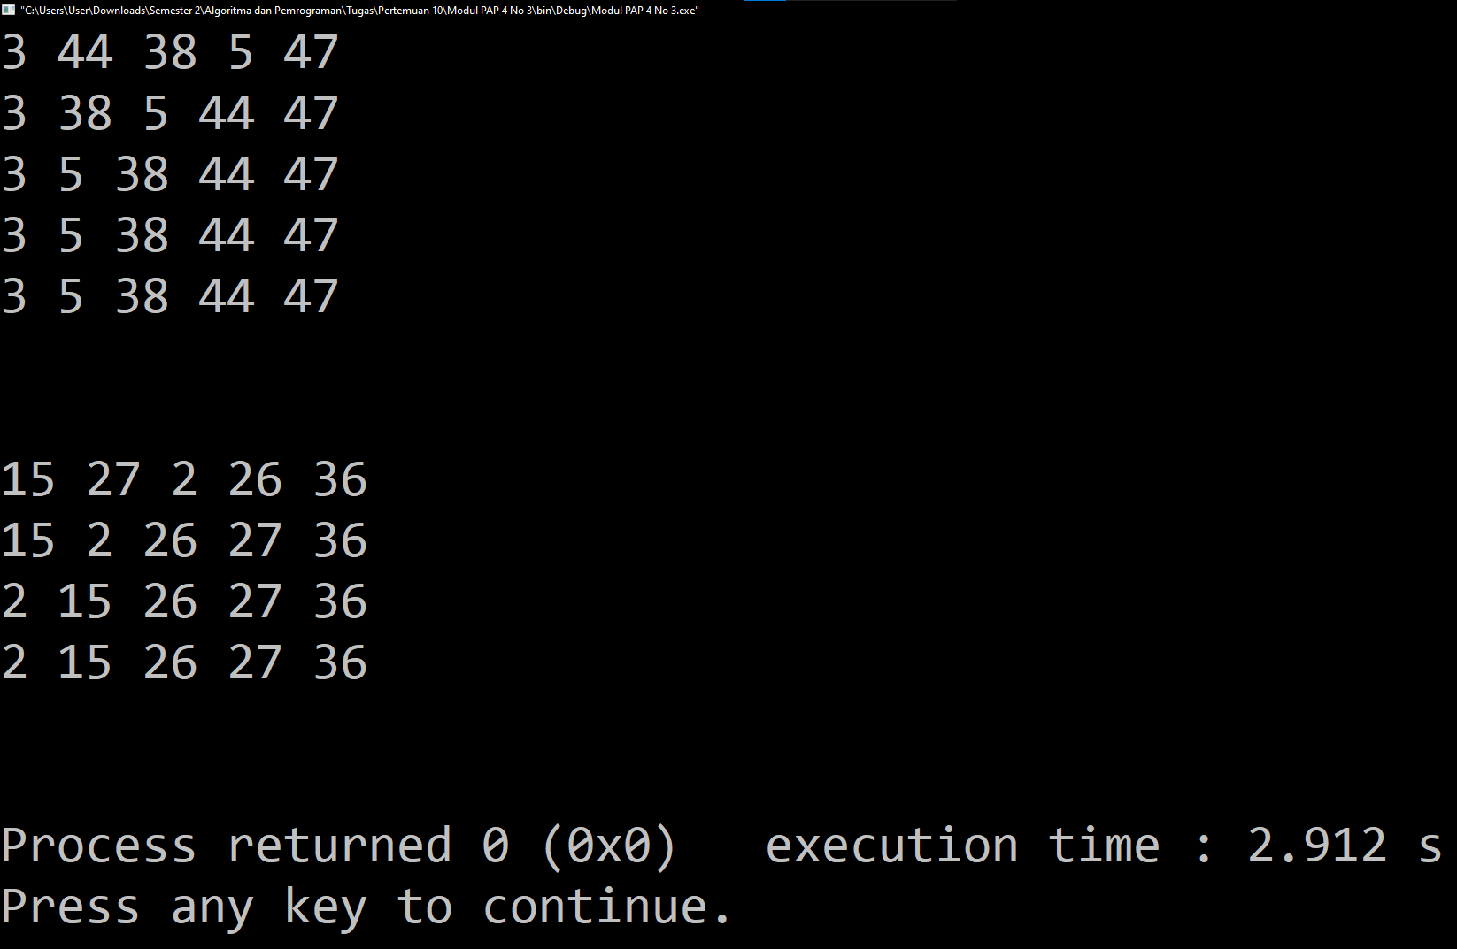

No 4

main.cpp

#include "pustaka.h"

#include <iostream>

using namespace std;

int main()

{

int arr1[] = { 3, 44, 38, 5, 47 };

int arr2[] = { 15, 36, 27, 2, 26 };

bubbleSort(arr1, 5);

cout << endl;

bubbleSort(arr2, 5);

cout << endl;

return 0;

}

pustaka.cpp

#include "pustaka.h"

#include <iostream>

using namespace std;

bool is_sort(int arr[], int length) {

bool is_sort = true;

int tempVal = 0;

for(int i = 0; i < (length+1); i++){

if(tempVal > arr[i]){

is_sort = false;

}

tempVal = arr[i];

}

return is_sort;

}

void bubbleSort(int arr[], int f) {

int i, j, temp;

int show = 0;

for(i=0; i<n-1; i++){

for(j=0; j<(n-i-1); j++){

if(arr[j]>arr[j+1]){

temp = arr[j];

arr[j] = arr[j+1];

arr[j+1] = temp;

}

}

int if_sort = is_sort(arr, (n-1));

if(show == 0){

for(int j=0; j<n; j++){

cout << arr[j] << " ";

}

cout << endl;

if(if_sort == 1){

show = 1;

}

}

}

}

pustaka.h

#ifndef PUSTAKA_H_INCLUDED

#define PUSTAKA_H_INCLUDED

bool is_sort(int arr[], int length);

void bubbleSort(int f[], int size);

#endif // PUSTAKA_H_INCLUDED

Hasil coding

